Table of Contents

Part A – Project Planning 2

*Overview* – 2

Requirements – 2

Other Requirements: 2

Expected Outcomes – 3

Technical details – 3

Part B – Database Design 5

EER Diagram – 5

Tables 6

Part C – Implementation and Testing 8

Database Creation 8

Relationship Between Tables 15

Database Testing 17

Database Population 21

Data Insertion 25

Deleting the data 26

Primary Keys in Tables 27

Testing Relationship Between Tables 30

EER Diagram 31

Data Export 32

References Used 33

# Part A – Project Planning

Overview –

I Ramanpreet working as a database designer at the Albert Football Club . Club helps players to take training , provide coaches and physios .Physios are different types . Club provides them ground to practice , proper diet and training kits to the players , only the members of the club have the access. Club have staff to take care of the players like manager , IT Admin , coaches and physio . Medical staff is also there for the players.

Requirements –

To create a repository of all the information and can be managed .

* User can update the data
* Insert the data
* Delete the data

It can be used by other clubs and can introduce many players .

Other Requirements:

Data about Players

* names,
* addresses,
* phone numbers.

Data about Physio

* Physio ID is the identifier of Physio
* Specialization (orthopedic, chiropractic, and acupuncture) ,
* name
* office addresses
* phone numbers

Data about Employees

* Employee_id,
* Employee_type
* Name of employee
* email of employee
* contact number of employees
* office addresses

Expected Outcomes –

* + ER diagram
  + Dump Files
  + Redundancy Avoidance
  + Database for saving data
  + Efficiency in maintaining data
  + Privacy
  + Backup

Technical details –

* + *DBMS Software*: *MySQL*

*The DBMS software MySQL is used which was initially a product of MySQL AB which is now owned by Oracle. It has various features for managing the database and various administration tools like backup , recovery , export and import data . Can also be used for migration also.*

* + *Tools : MySQL Workbench*

For visualization and managing data MySQL Workbench is used. This tool can be used to create , delete objects in the database like tables, views etc.

* + *Backup:*

*For data to be secure , it needs a backup which can be used to restore the data in case of database failures.*

*Backup Methods*

* + 1. Full Backup

Full copy of database kept in a different drive

* + 1. Transaction Log

Transaction log for of the transaction periodically is backed up

* + 1. Differential Backup

The Difference of the data is backed up.

Backup Schedule:

**Monday:** Full backup

**Tuesday To Saturday**: Full Backup

**Sunday**: Differential Backup

* + *Recovery*

It can be done in two ways.

* + 1. **Log based recovery** -  Logs are used to recover the data.
    2. **Shadow paging -** All the data needs to have copy along with the log.

# Part B – Database Design

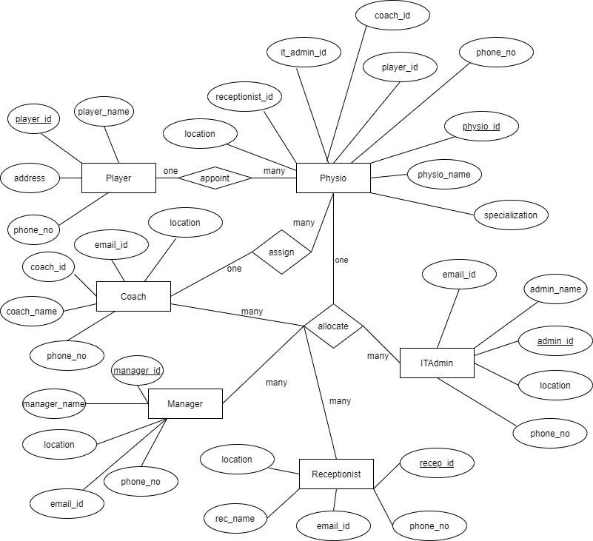EER Diagram –

Tables

First Normal Form

Physio Table Player Table Employee Table

Physio_id Player_id employee_id

Physio_name Player_name employee_type

Location address employee_name

Phone_no phone_no email_id

Physio_specialization phone_no

Location

Second Normal Form

Physio Player Receptionist Manager IT Admin Coach

Physio_id Player_id receptionist_id manager_id admin_id coach_id

Physio_name Player_name receptionist_name manager_name admin_name coach_name

Location address email_id email_id email_id email_id

Phone_no phone_no phone_no phone_no phone_no phone_no

Physio_spec location location location location

Third Normal Form

Physio Player Receptionist Manager IT Admin Coach

Physio_id Player_id receptionist_id manager_id admin_id coach_id

Physio_name Player_name receptionist_name manager_name admin_name coach_name

Location address email_id email_id email_id email_id

Phone_no phone_no phone_no phone_no phone_no phone_no

Physio_spec location location location location

Player_id

Receptionist_id

Coach_id

Manager_id

Admin_id

# Part C – Implementation and Testing

Database Creation

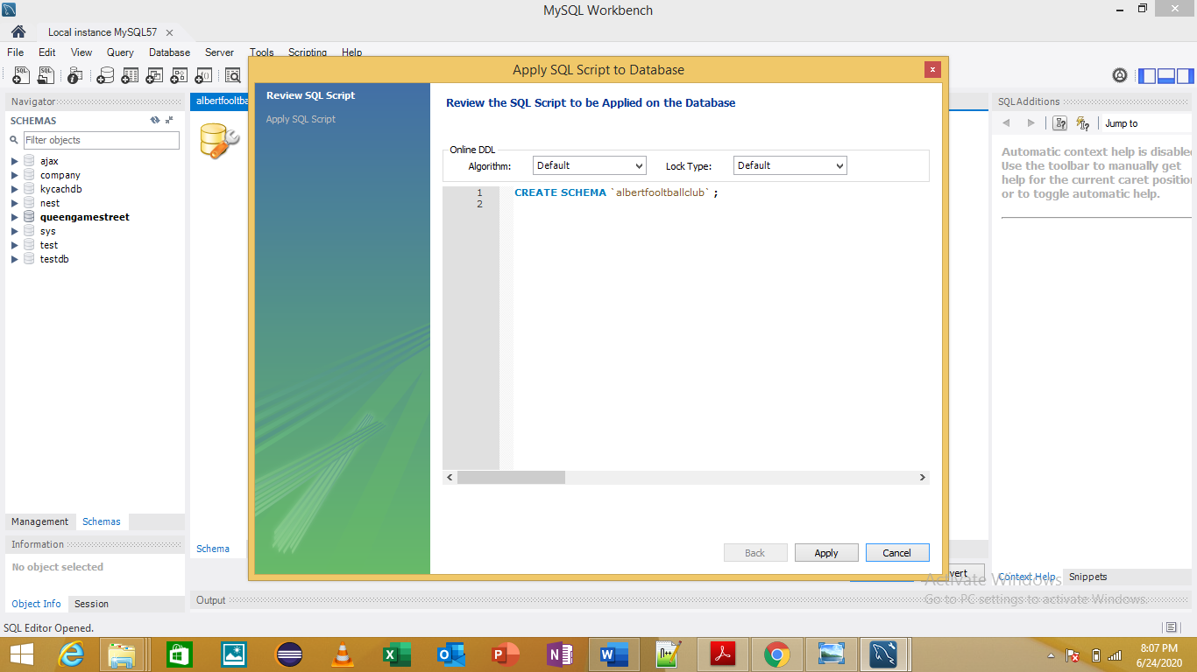

Player Table

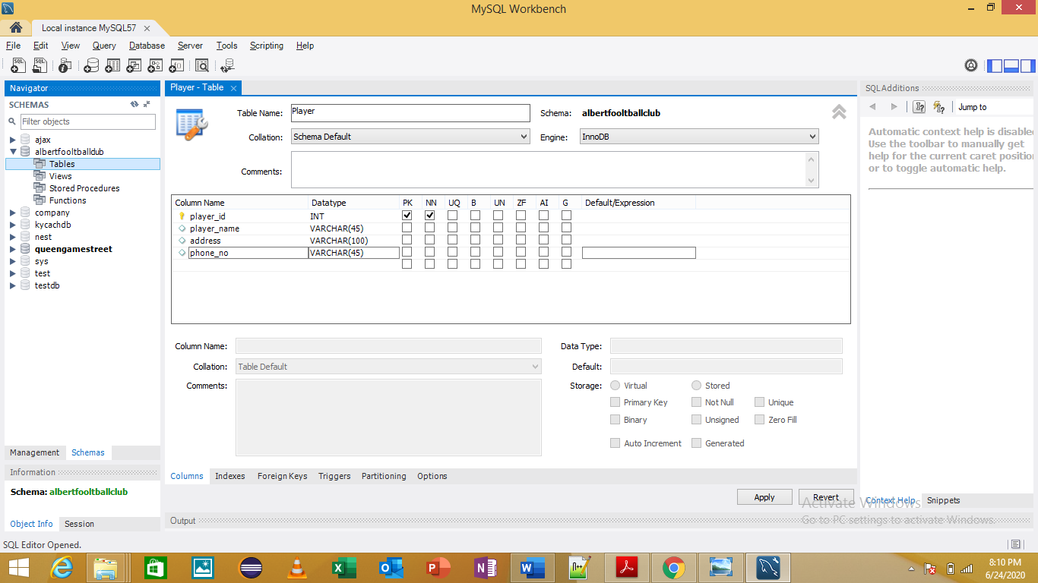

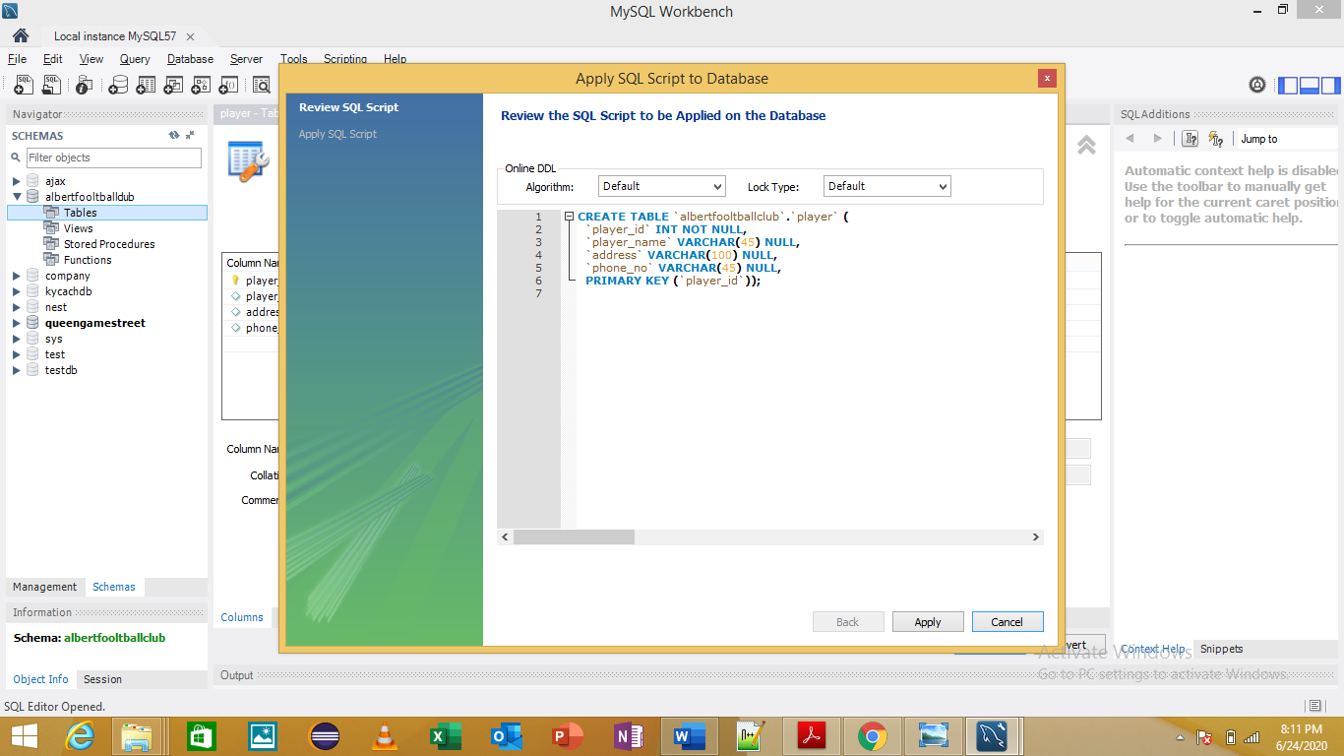

Receptionist Table

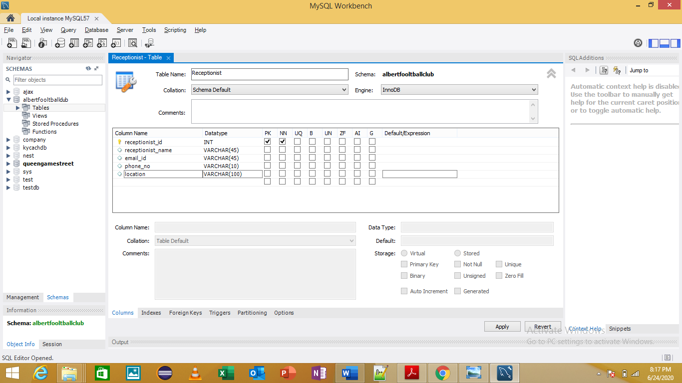

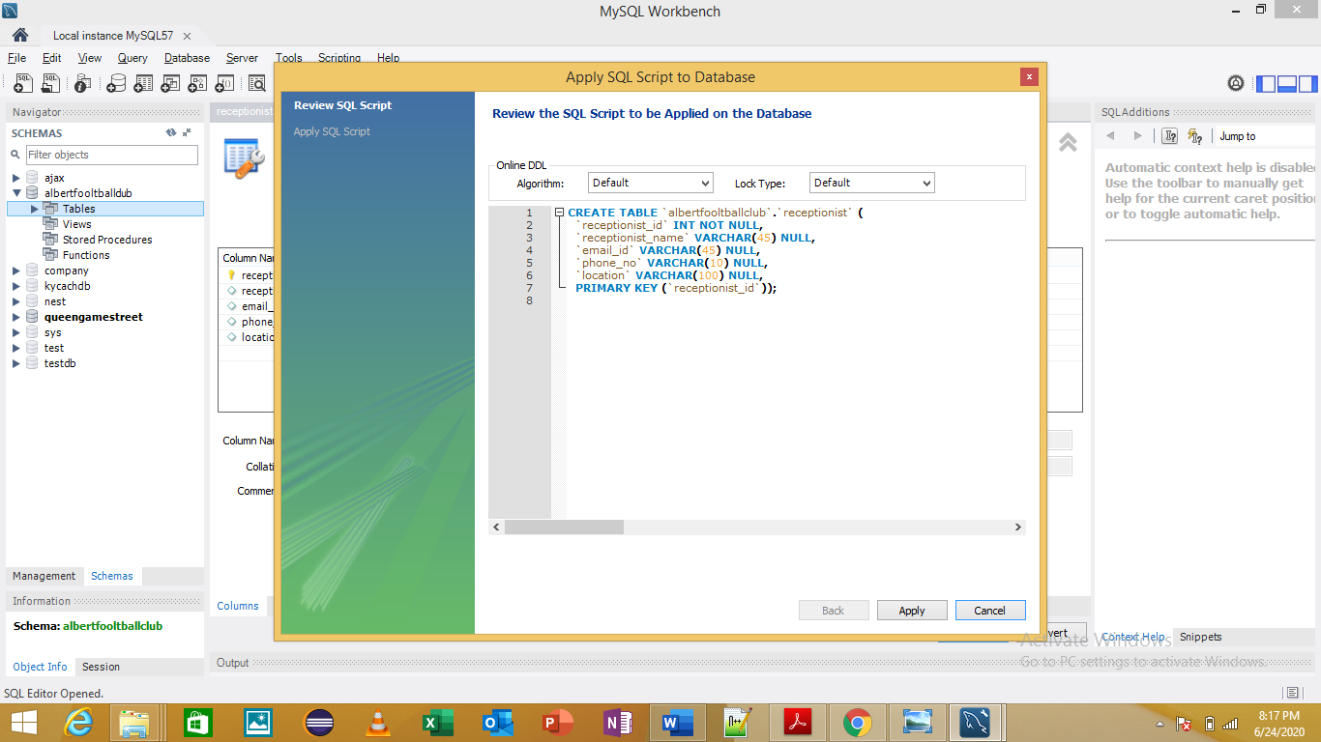

Manager Table

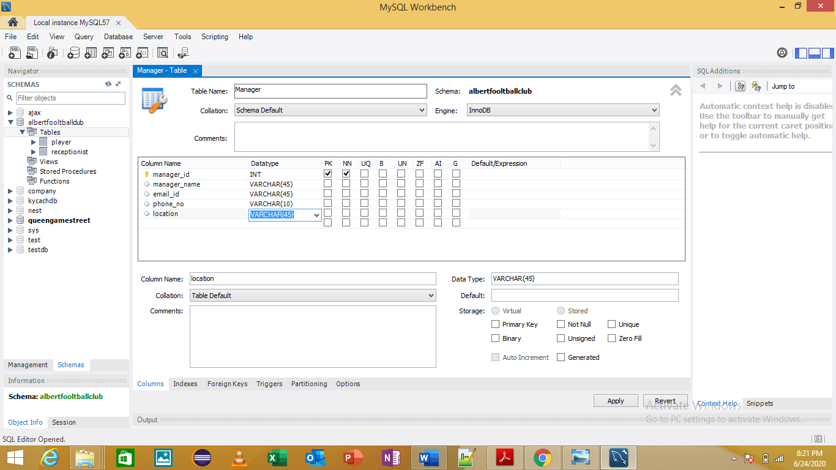

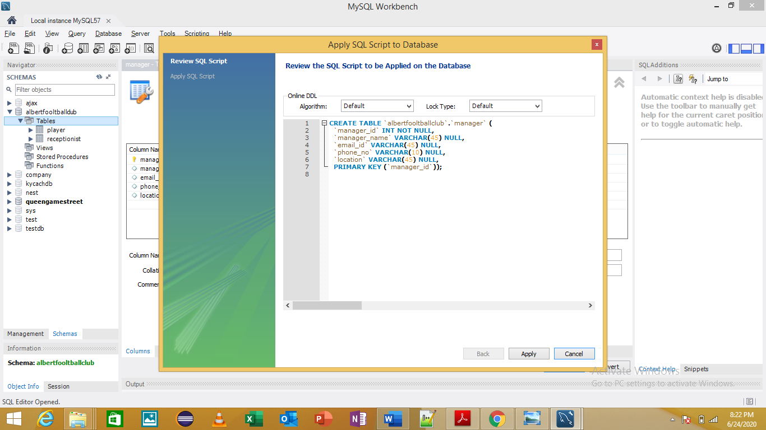

ITAdmin Table

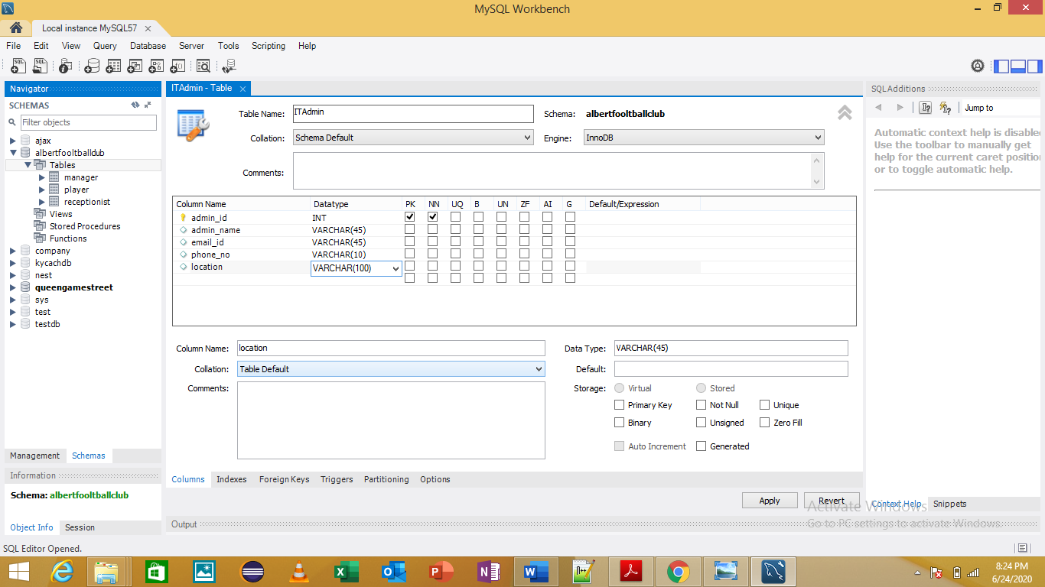

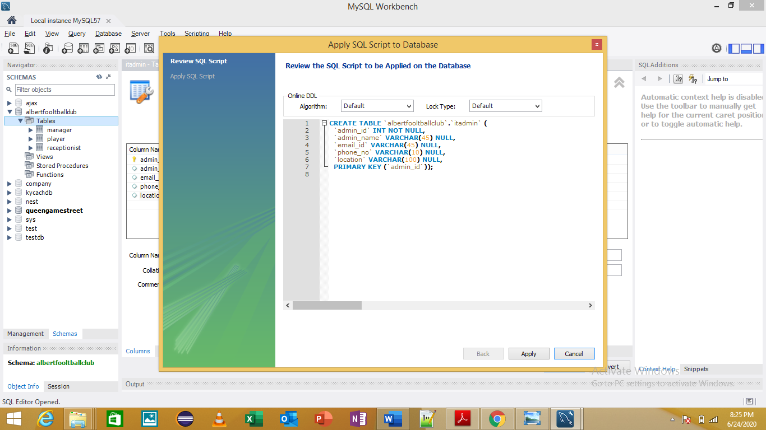

Coach Table

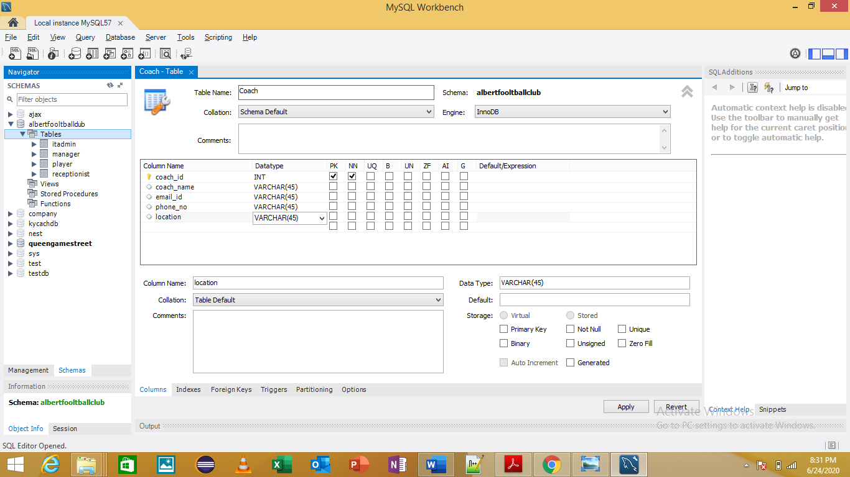

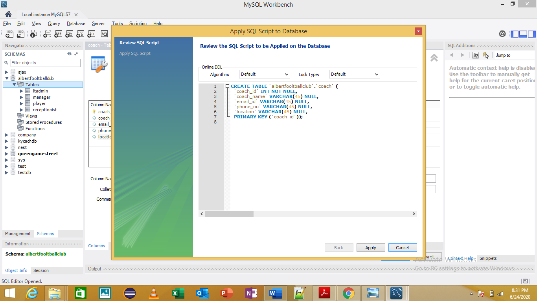

Physio Table

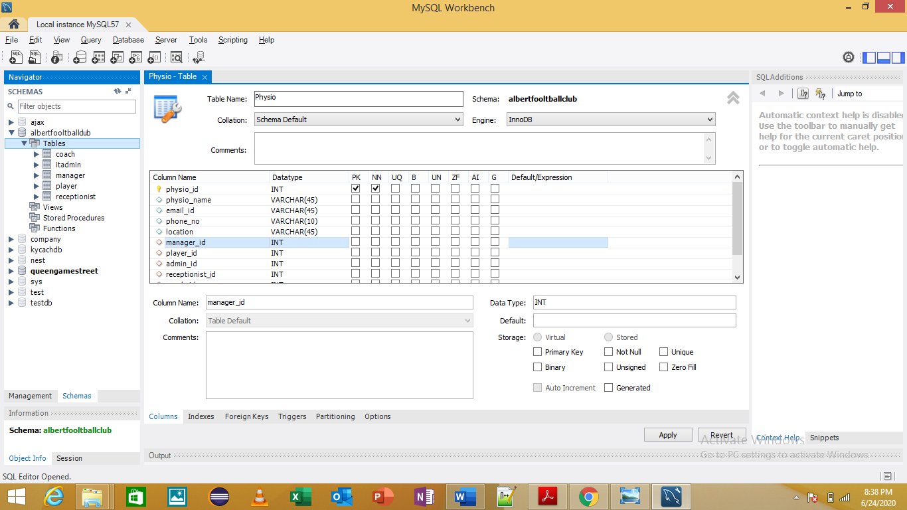

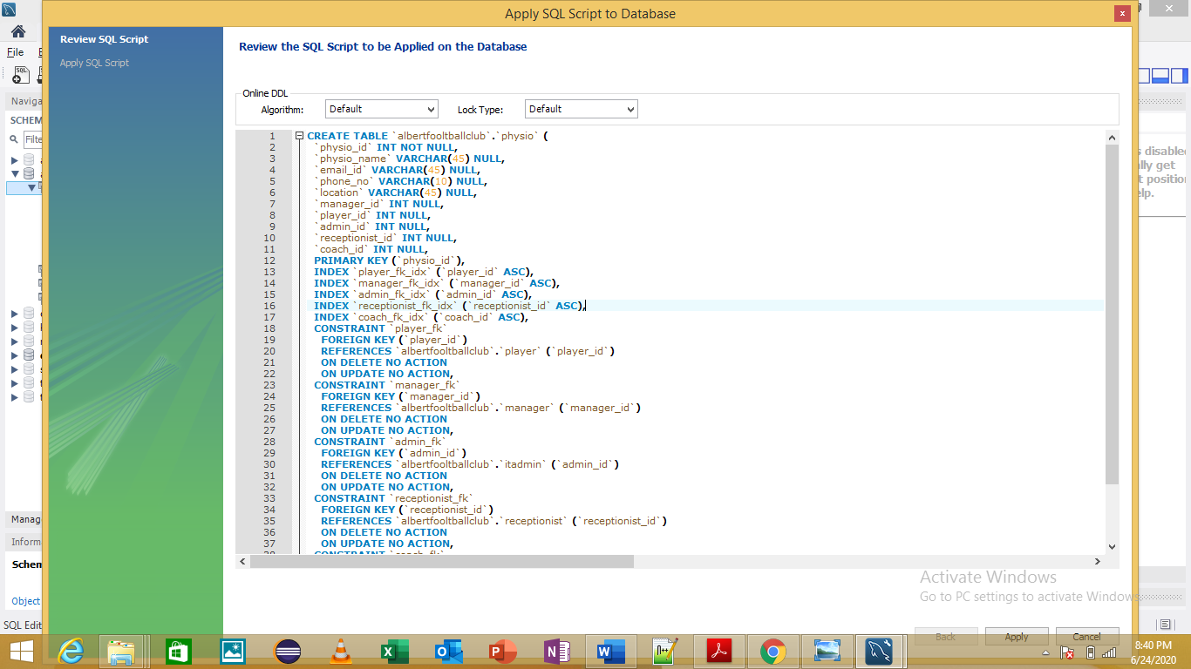

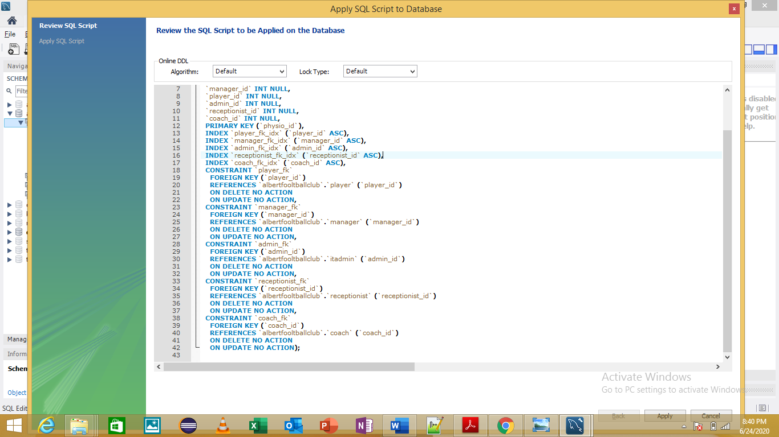

## Relationship Between Tables

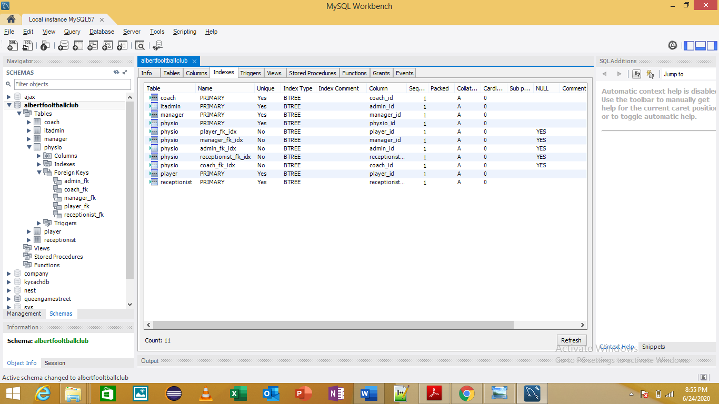

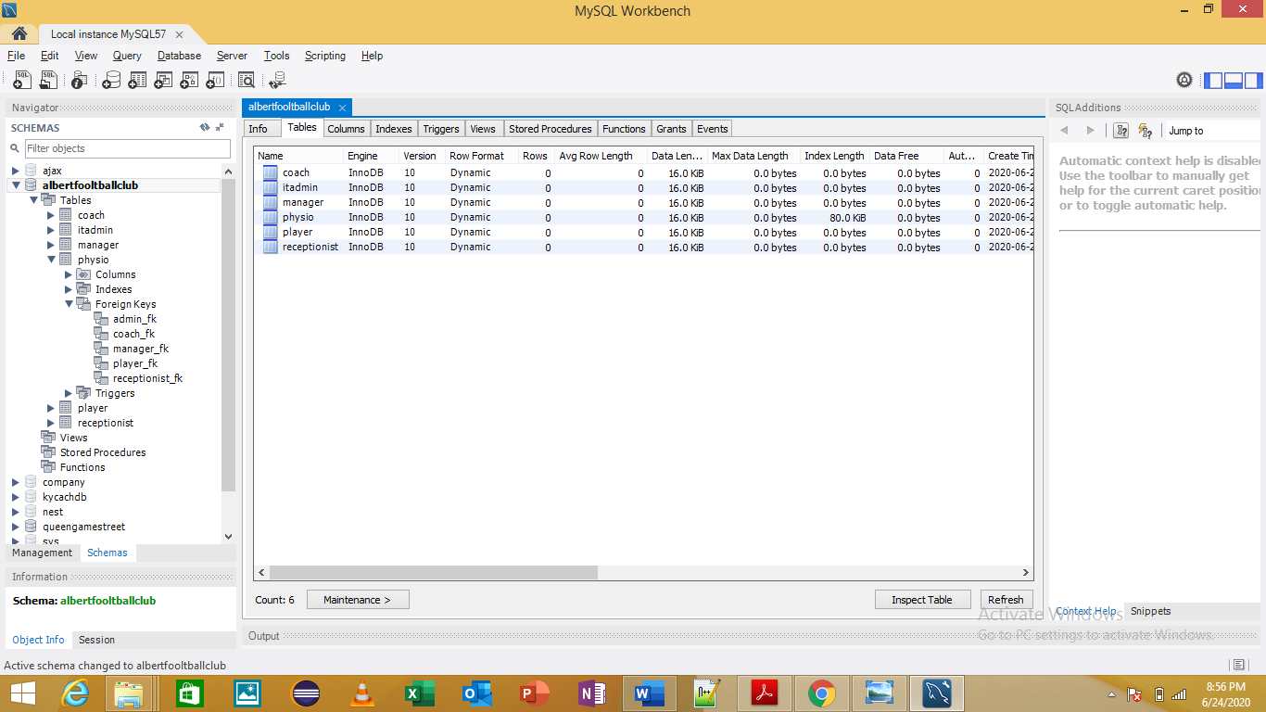

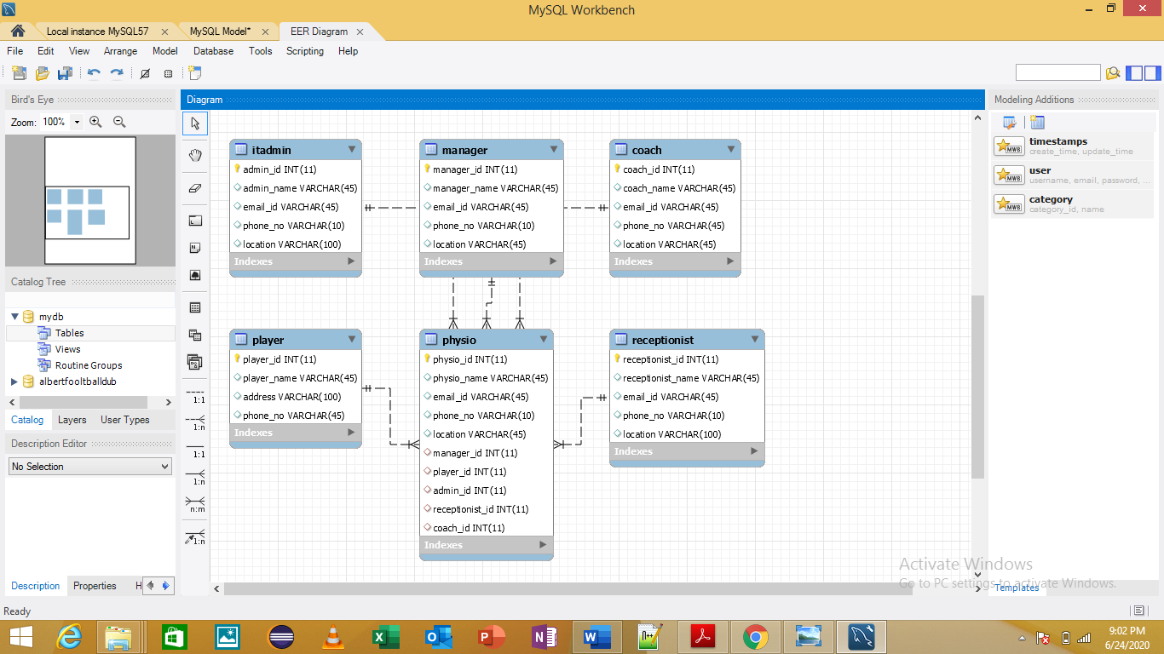

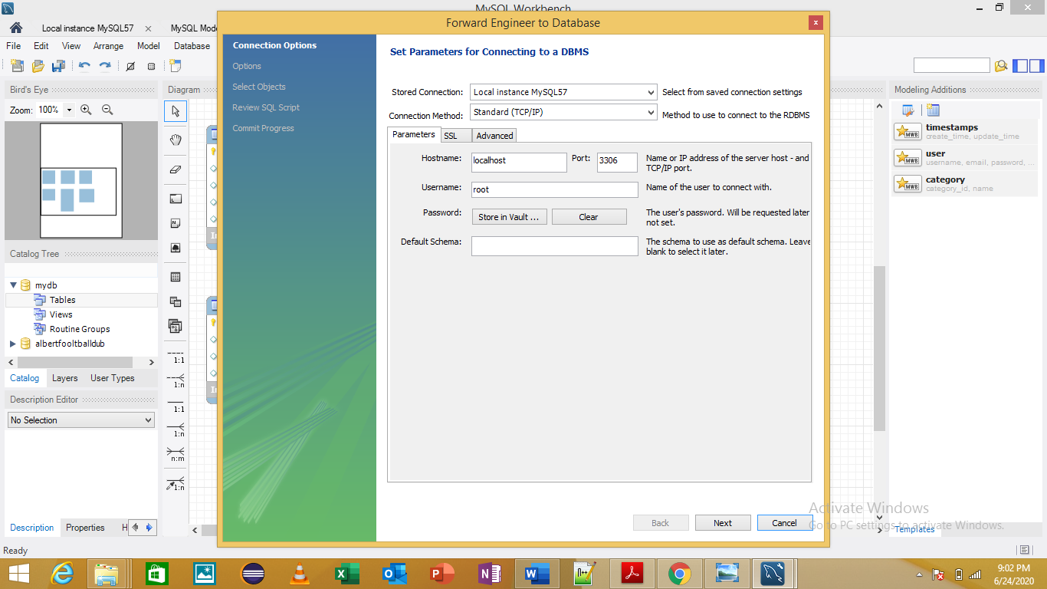Database Testing

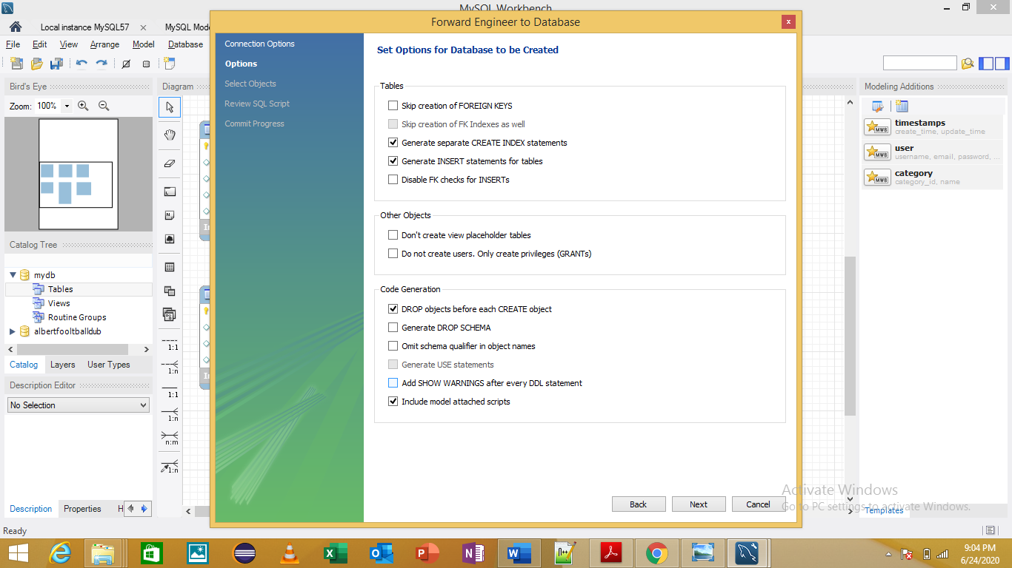

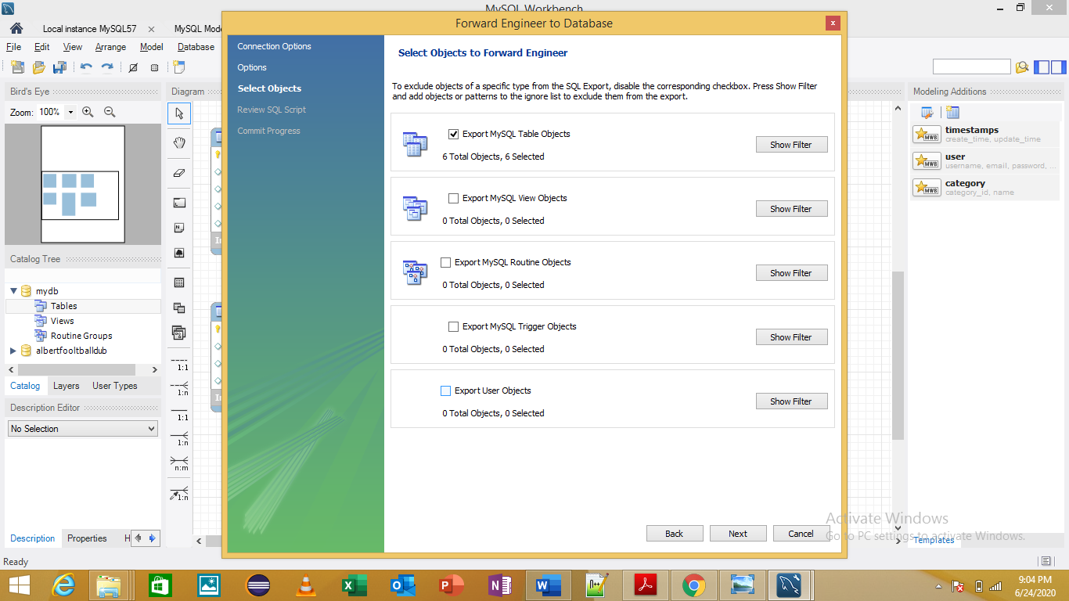

Coach Table

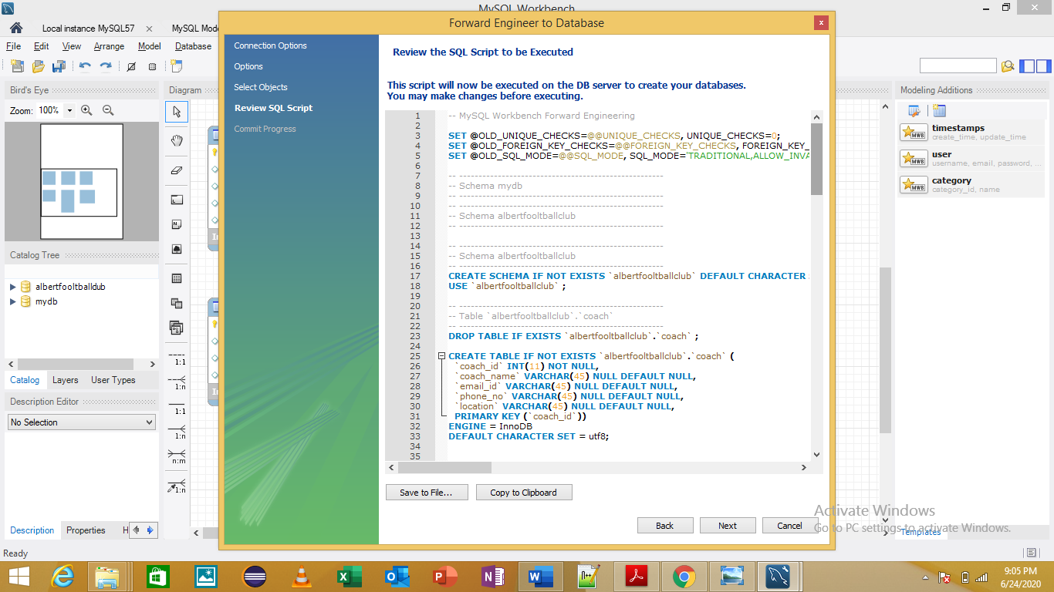

IT Admin and Manager Table

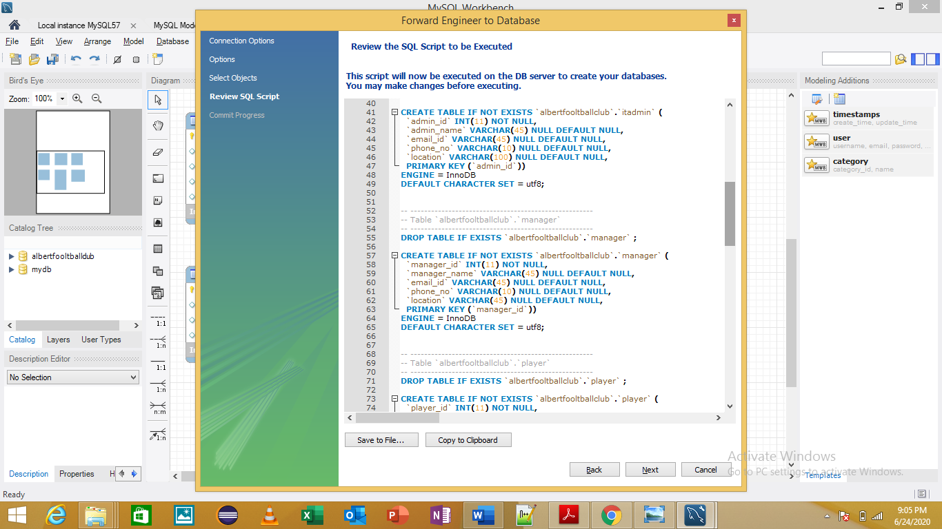

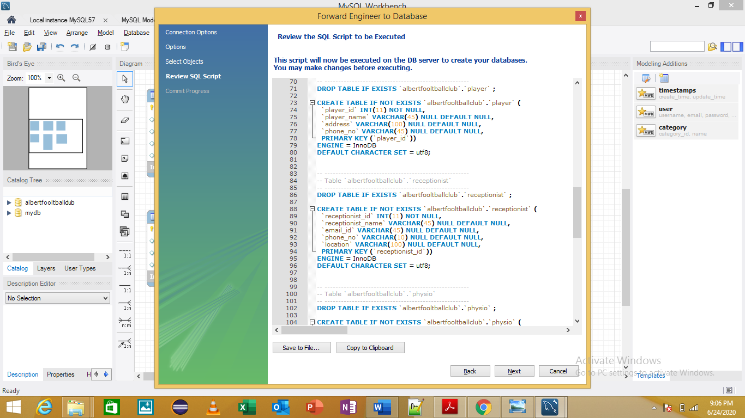Player and Receptionist Table

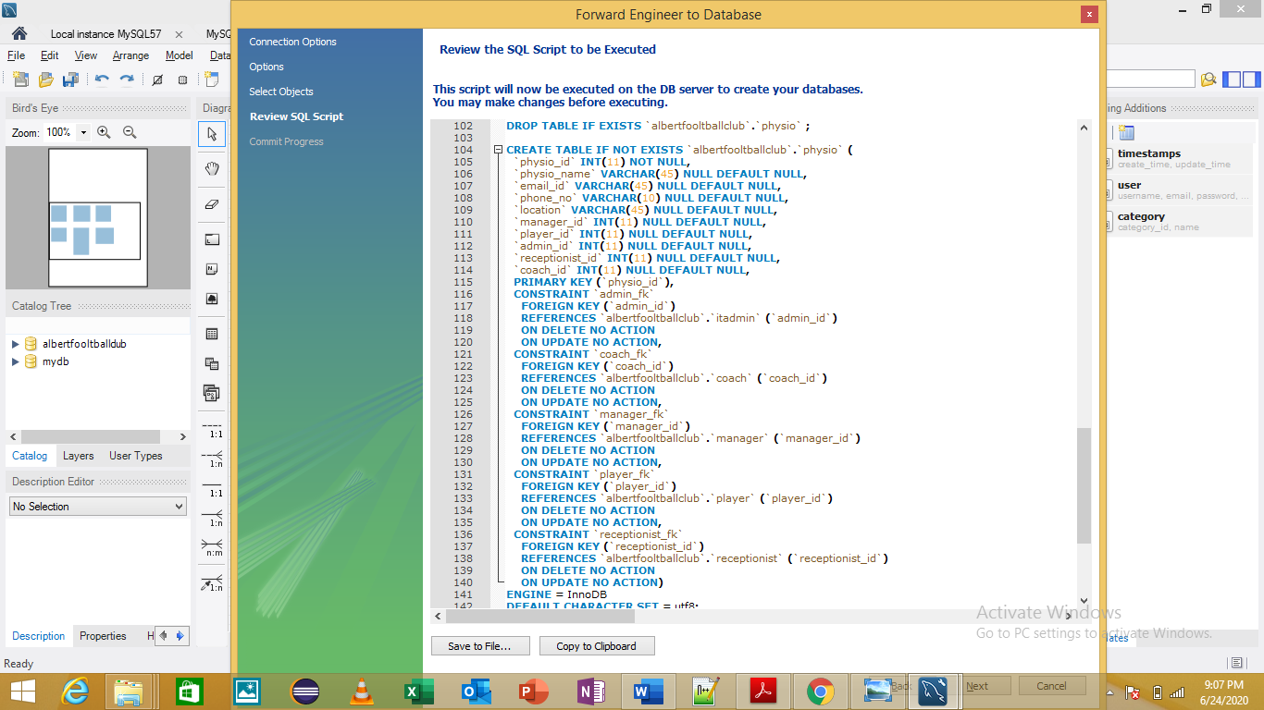Physio Table

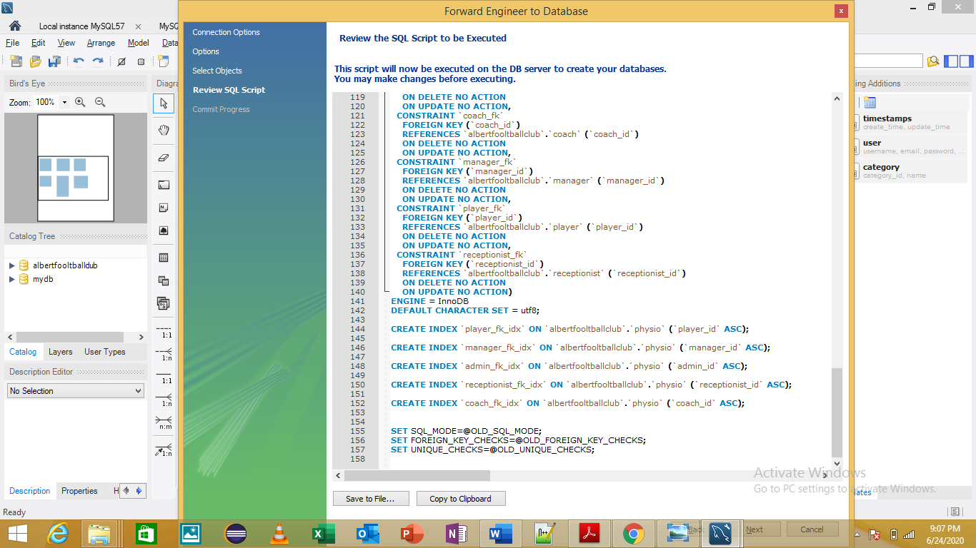Indexes

## Database Population

Manager Table

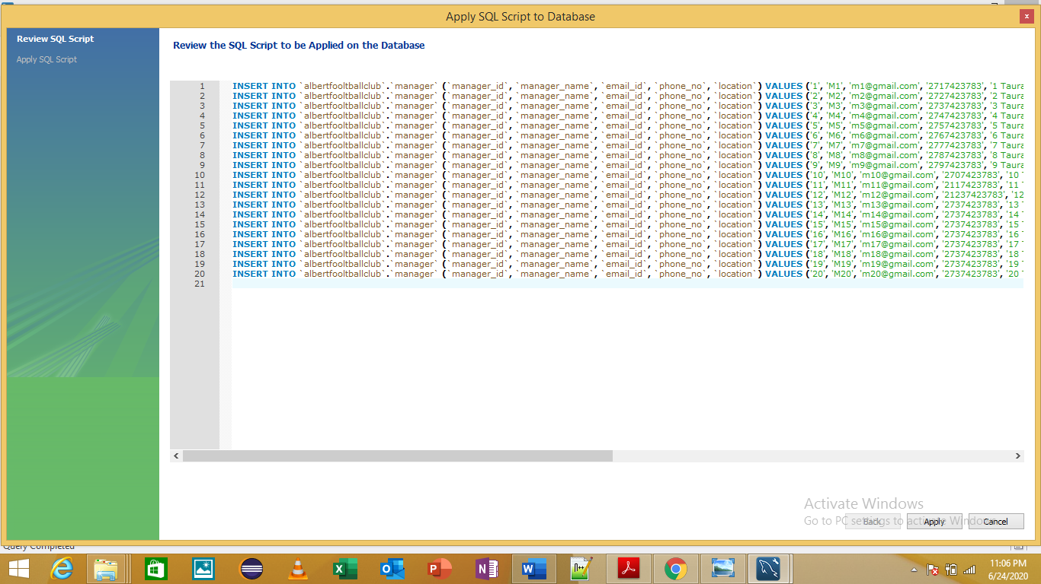

PLAYER

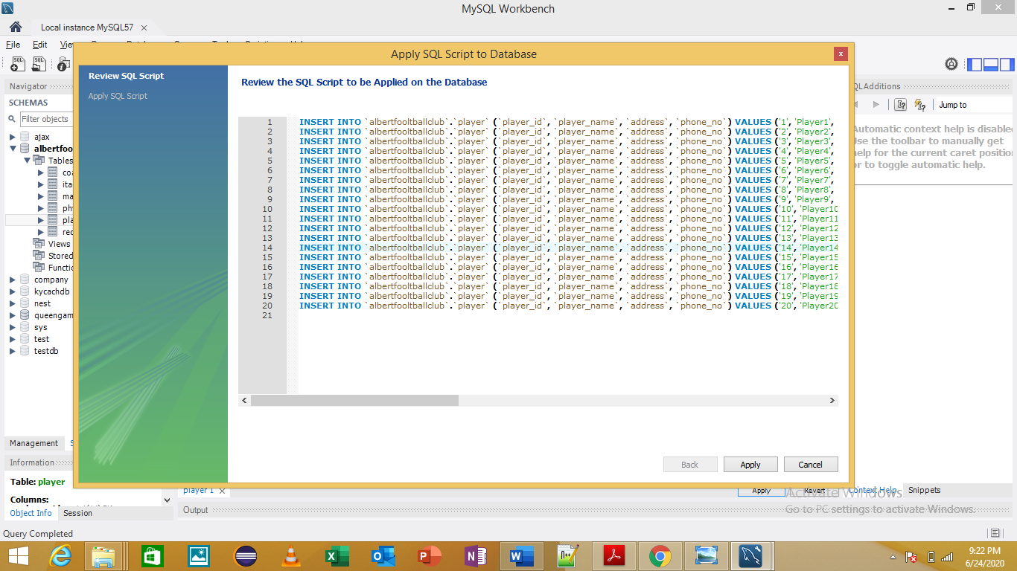

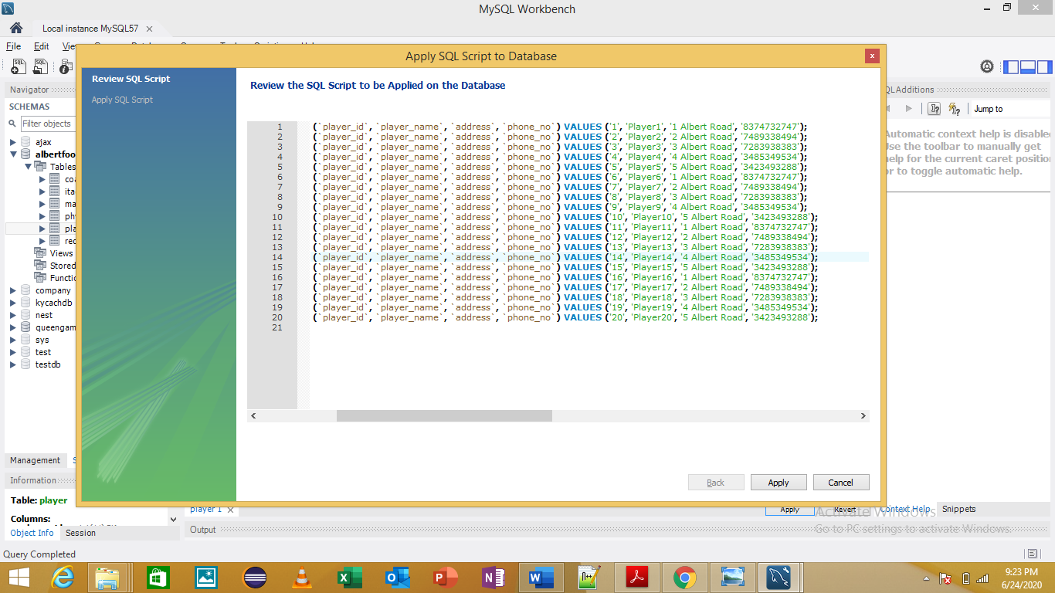

Coach Table

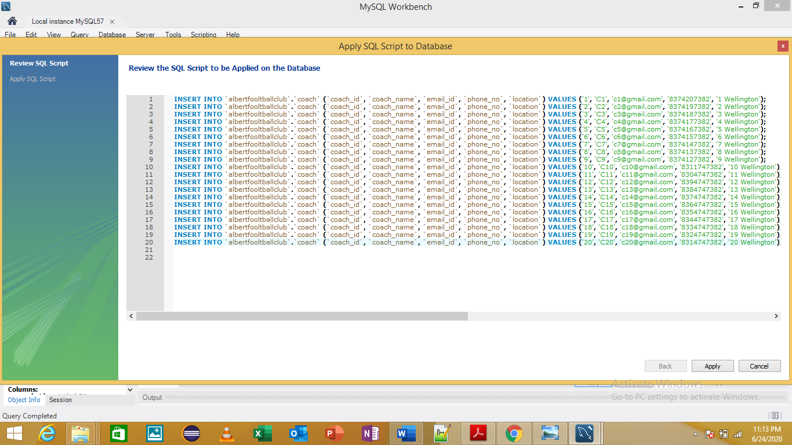

Receptionist Table

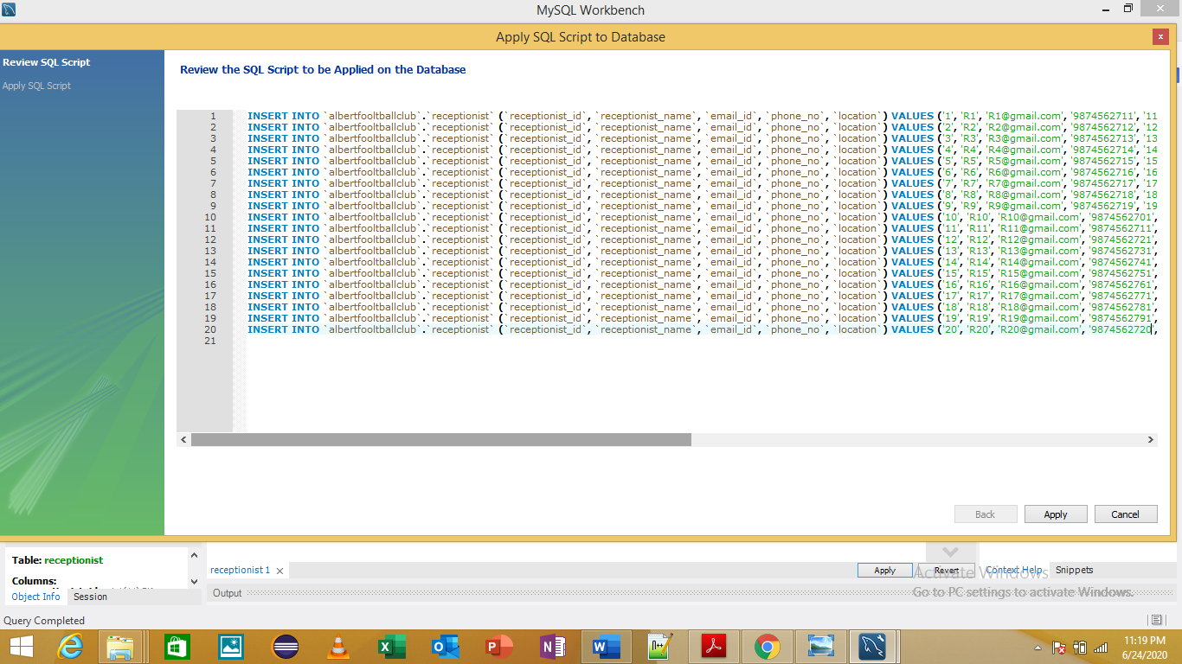

Physio Table

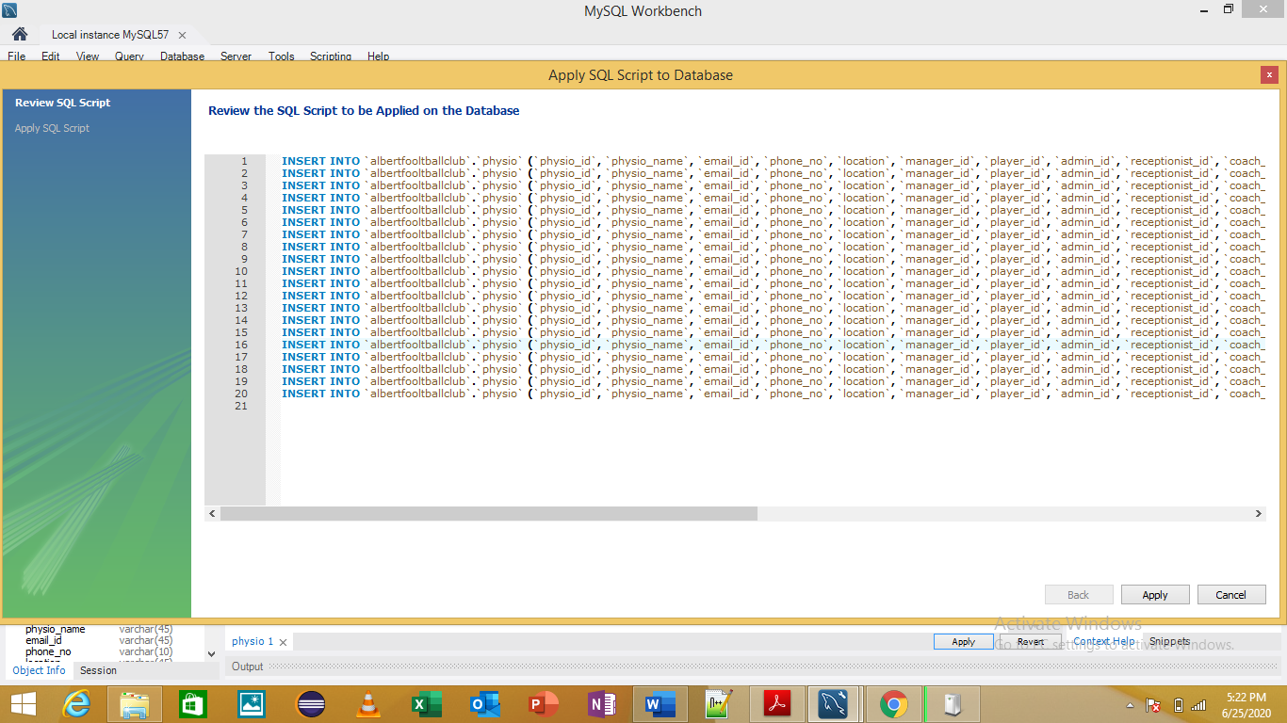

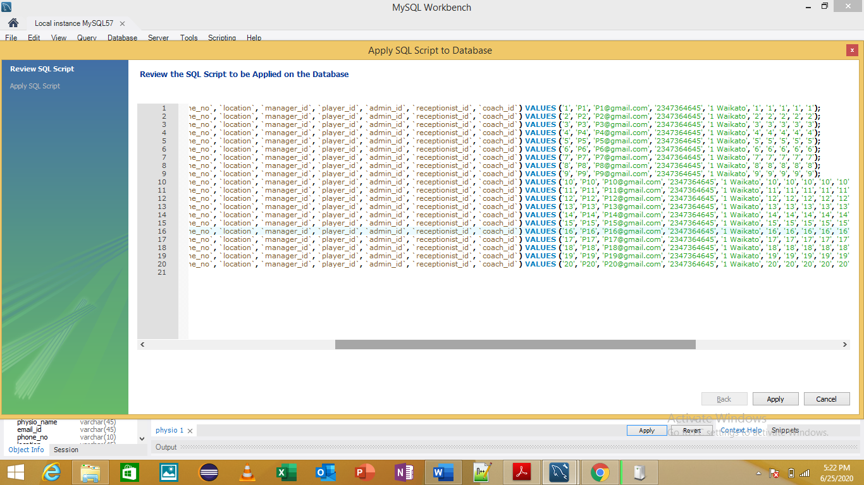

ITAdmin Table

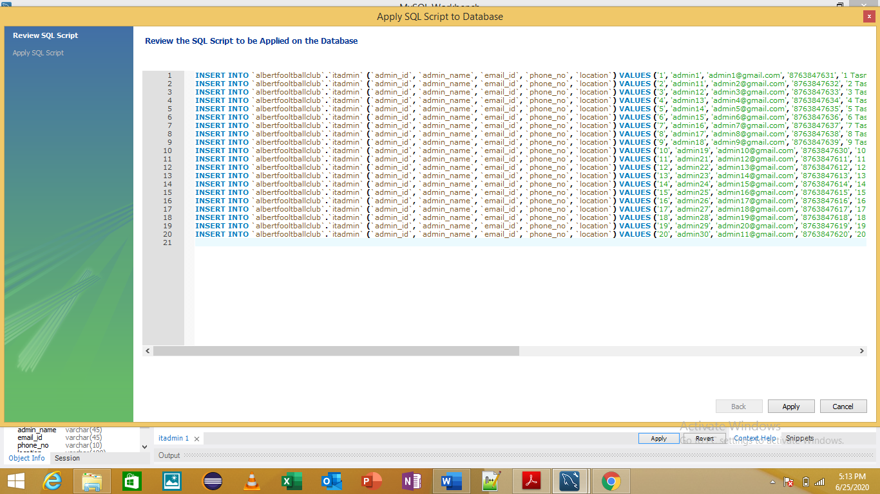

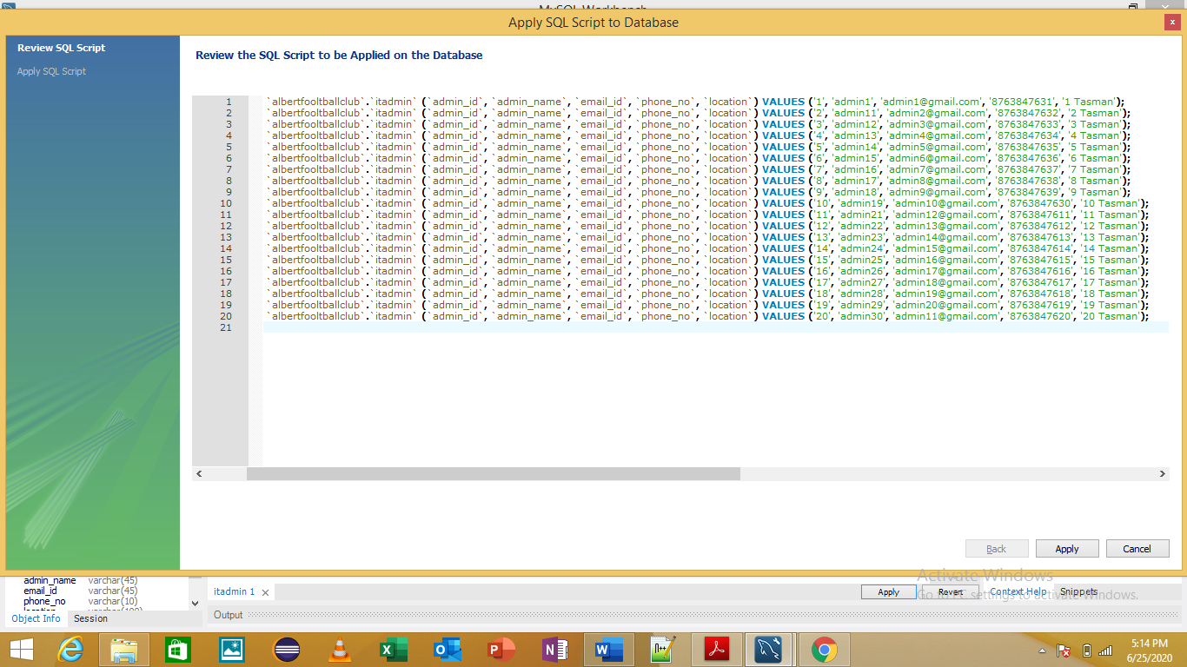

## Data Insertion

Before

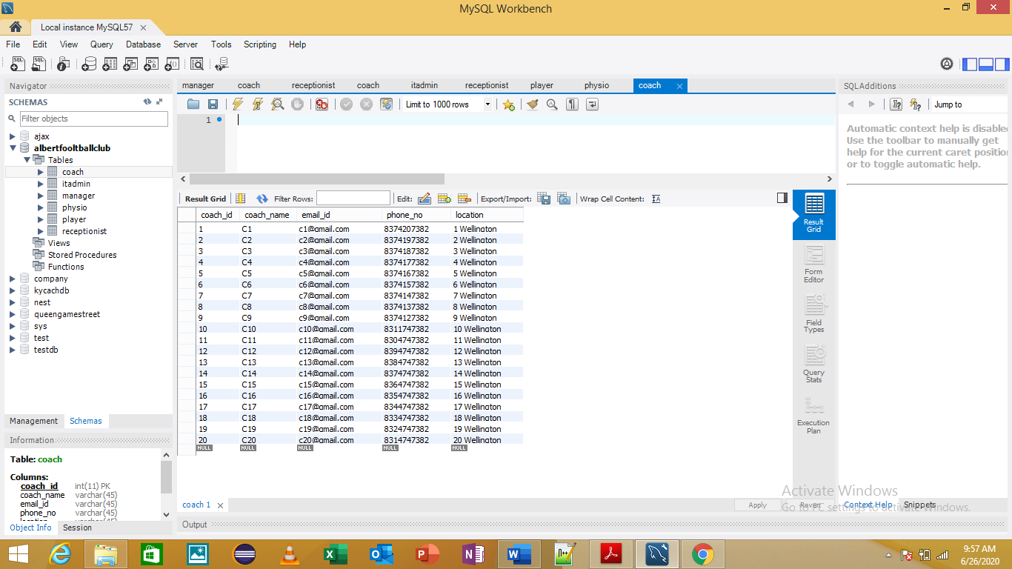

After

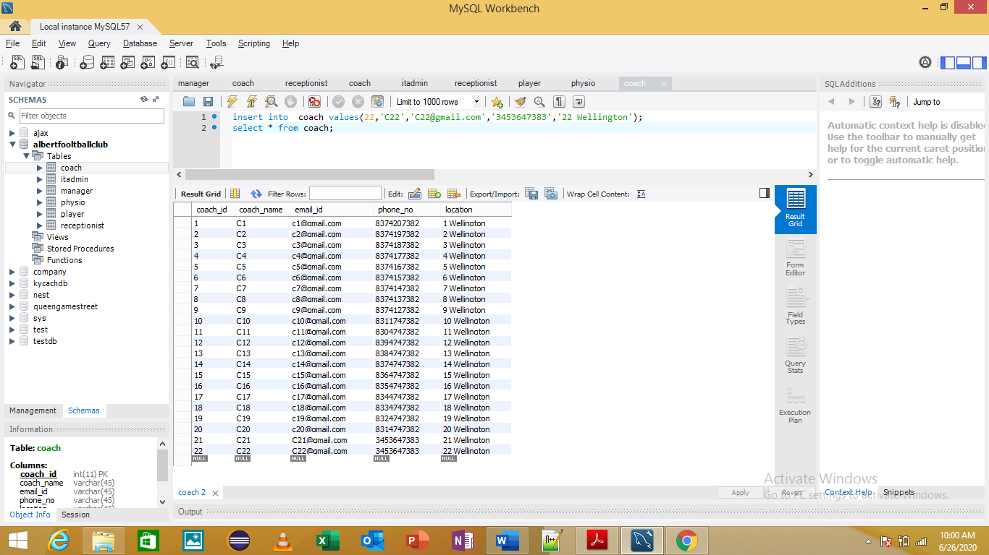

## Deleting the data

Before

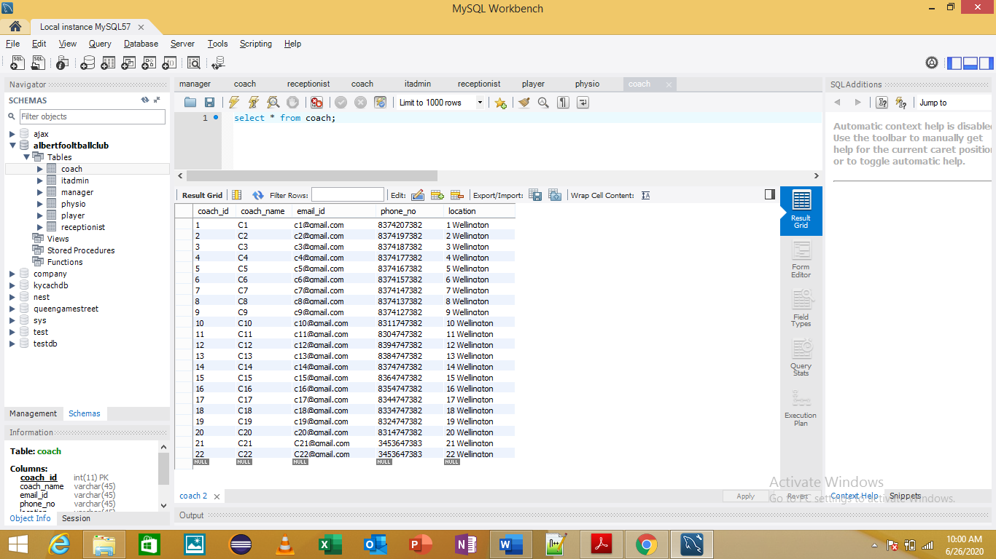

After

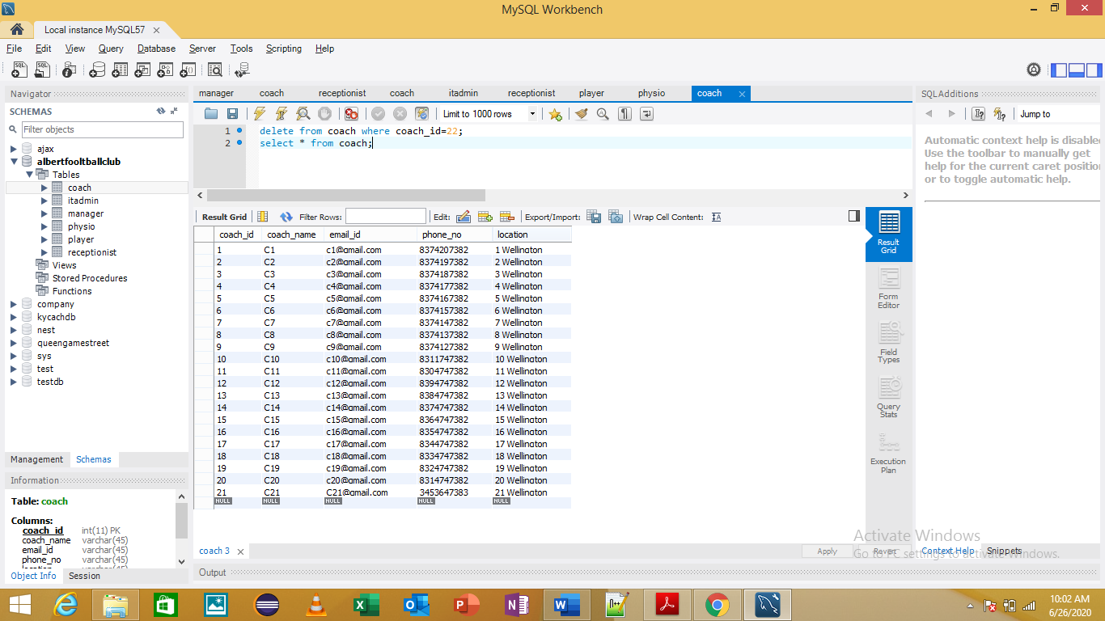

## Primary Keys in Tables

Receptionist Table

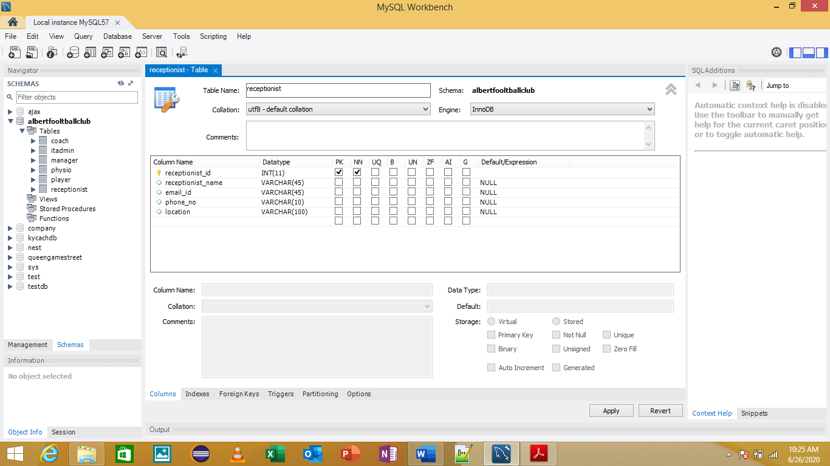

Player Table

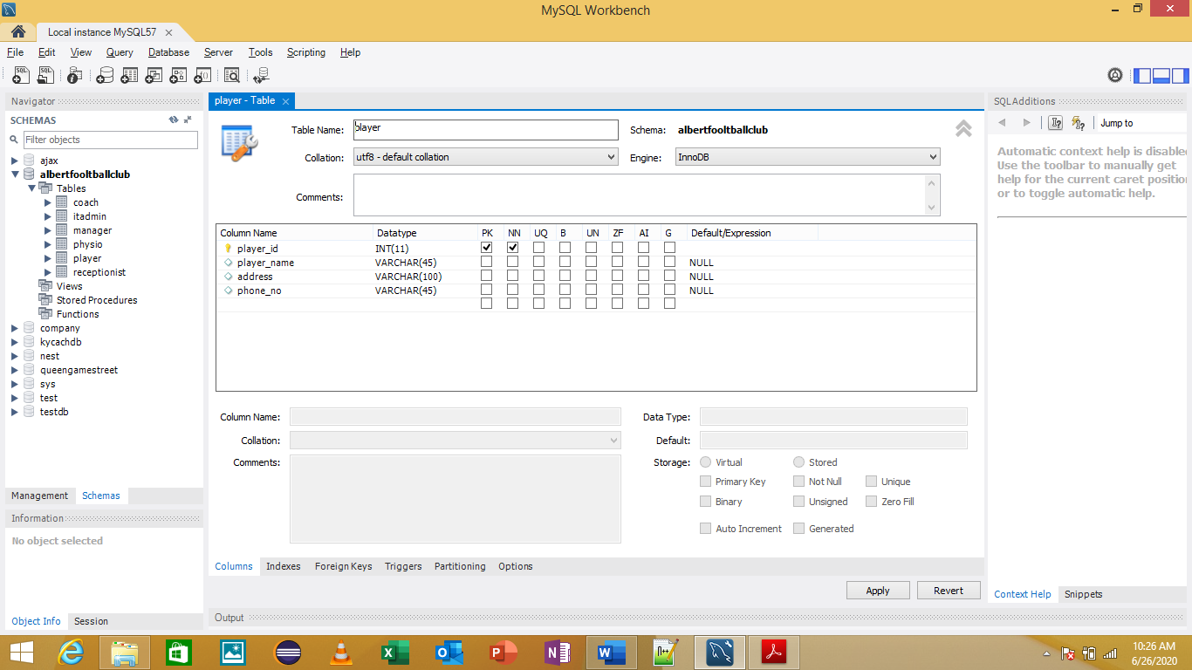

Manager Table

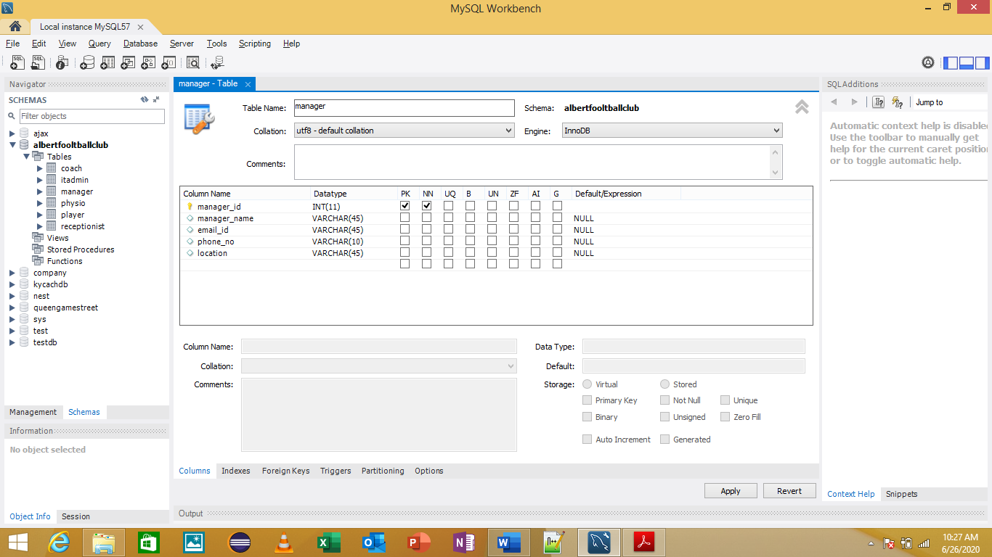

IT Admin Table

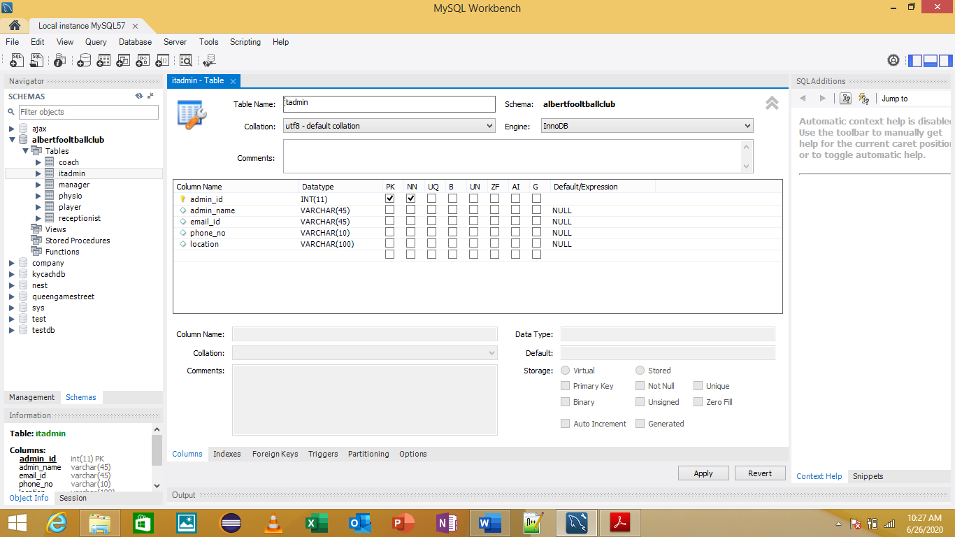

Coach Table

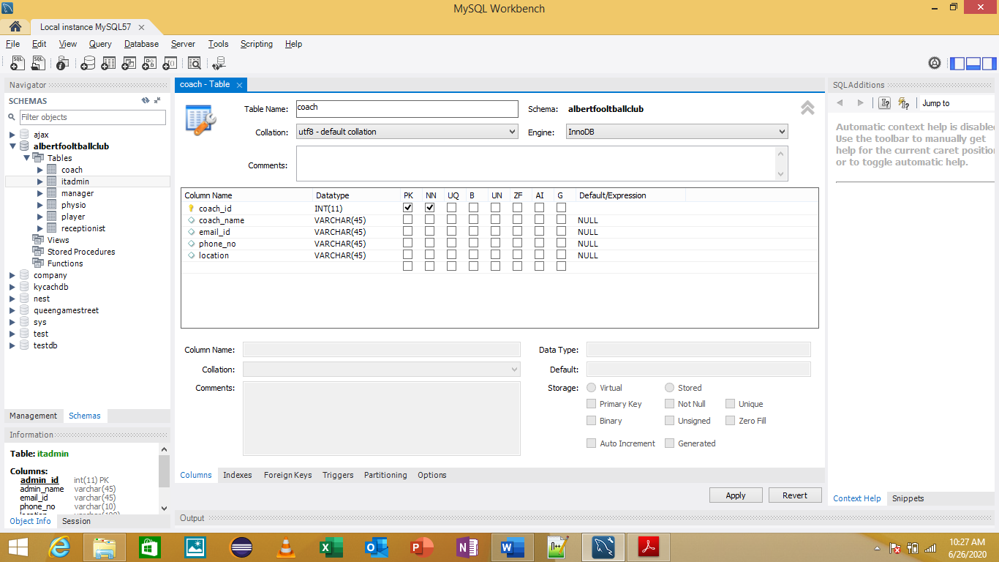

Physio Table

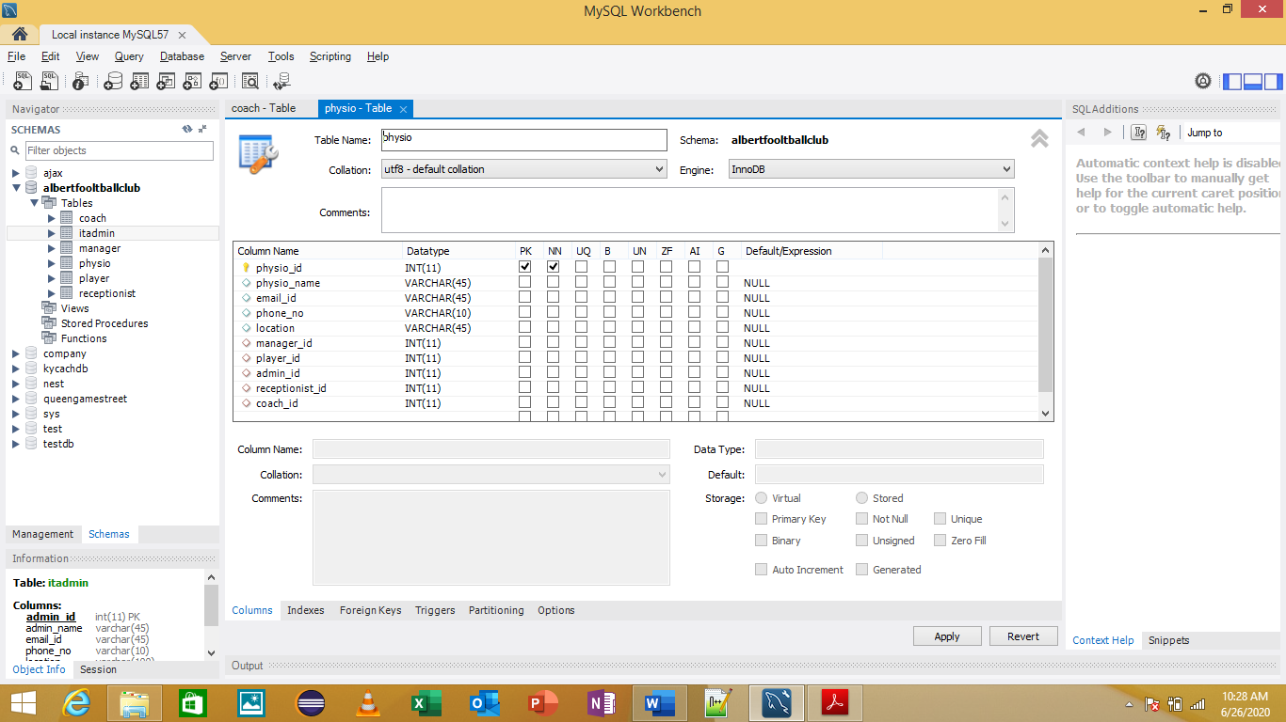

## Testing Relationship Between Tables





## EER Diagram



## Data Export

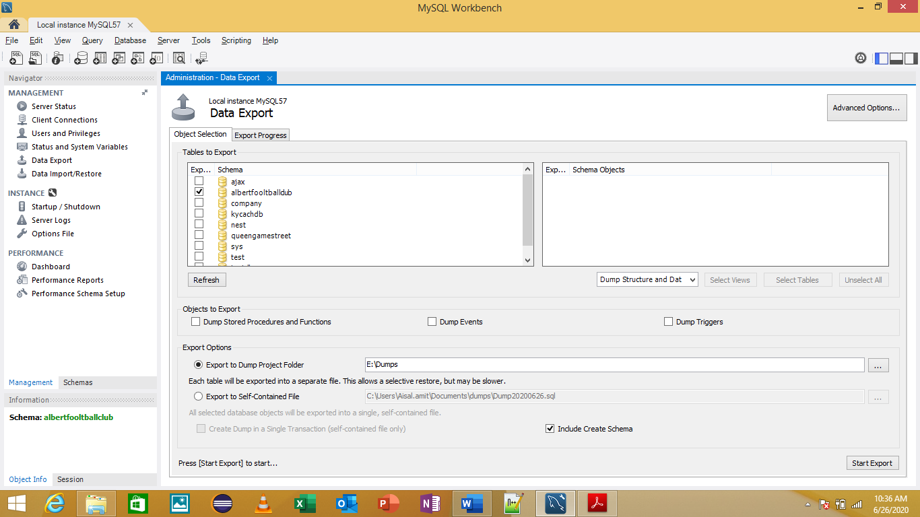

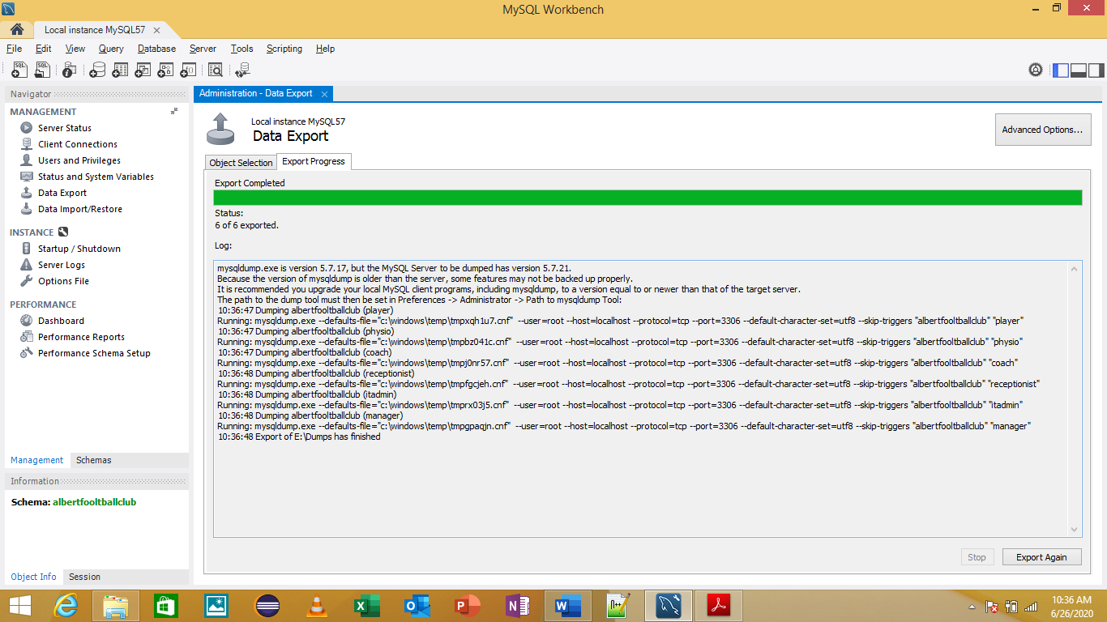

# References Used

* Backup and Recovery retrieved from <https://www.tutorialspoint.com/Database-Backup-and-Recovery> and <https://phoenixnap.com/kb/how-to-backup-restore-a-mysql-database>
* EER Diagram retrieved from <https://dev.mysql.com/doc/workbench/en/wb-creating-eer-diagram.html>
* Schema Creation retrieved from <https://dev.mysql.com/doc/refman/8.0/en/create-database.html>
* Technical Details – MySQL Introduction retrieved from <https://www.tutorialspoint.com/mysql/mysql-introduction.htm>
* Export Data In MySQL retrieved from <https://www.tutorialspoint.com/mysql/mysql-database-export.htm>
* Export Data in MySQL Workbench retrieved from <https://dev.mysql.com/doc/workbench/en/wb-admin-export-import-management.html>
* Expected Outcomes referenced from <https://www.scribd.com/doc/117344094/Sample-Objective-and-Outcome-for-Dbms-and-Lab>
* Technical Details – MySQL Workbench retrieved from <https://dev.mysql.com/doc/workbench/>